AIR University, Islamabad
Department of Software Engineering
Subject: Software Engineering Concepts
Assignment # 04
─────────────────────────────────

Student Name
Muhammad hamza khan | Awais Bajwa
Registration Number
2502941 | 2502857
Supervisor name
Sir Zulfiqar Ali
Class / Section
BSSE-II-A
Assignment No. | 4
Project title | Gym Fitness and tracking portal system
Date of submission | 5/6/2026
AIR University, Islamabad

Question 1
This question involves designing the user interface using Figma, implementing two modules of the FitTrack Fitness Management System, and recording a demo video.

1.1 UI Design – Figma
The user interface for the FitTrack Fitness Management System was designed using Figma. The design covers all major screens including Dashboard, BMI Calculator, Workout Plan, Nutrition Tracking, Progress, Trainer Chat, and Exercise Library. The prototype was built with proper navigation flows and interactive components.

Figma Public Link: https://www.figma.com/make/EzPGeQeUyzvHIXUPzFmG4R/Gym-Fitness-Management-System--Copy-?t=DWfUnlJsq9JFAaYo-1

UI Screens – FitTrack Fitness Management System
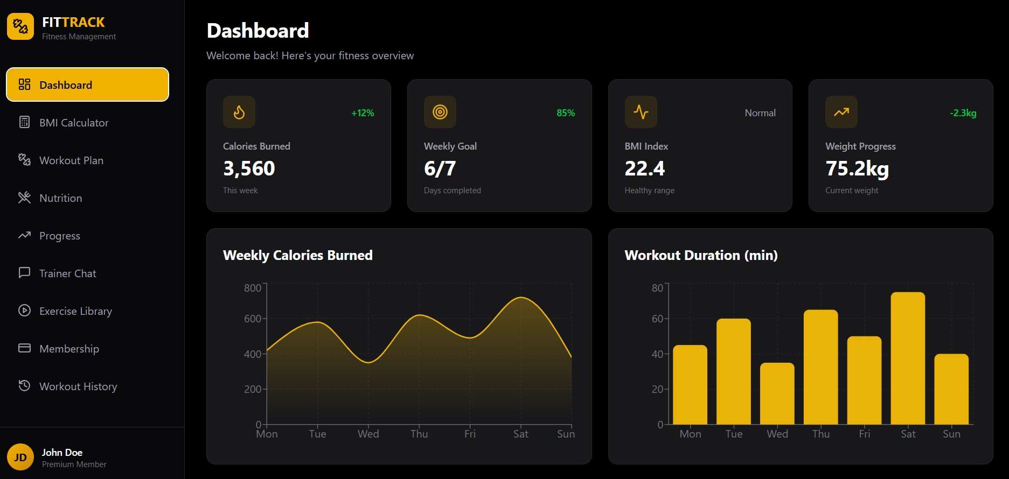
Figure 1: Dashboard – Overview of calories burned, weekly goal, BMI index, and weight progress with charts
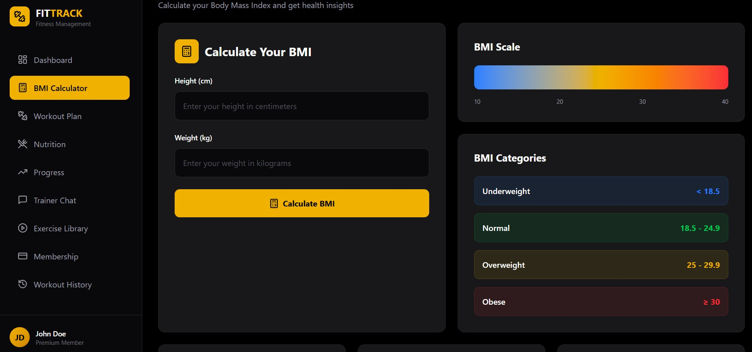
Figure 2: BMI Calculator – Calculate Body Mass Index with health category reference scale
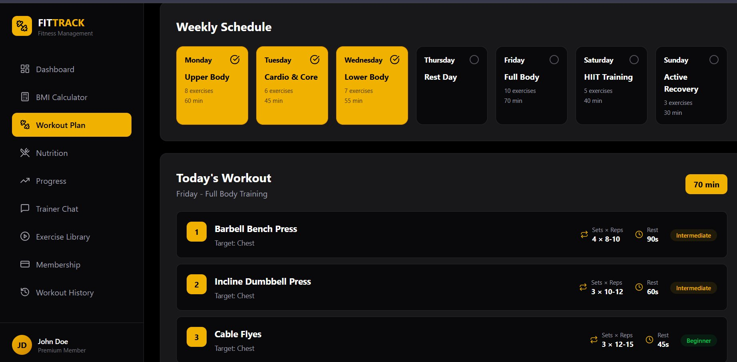
Figure 3: Workout Plan – Weekly schedule showing daily workout types and today's exercise list
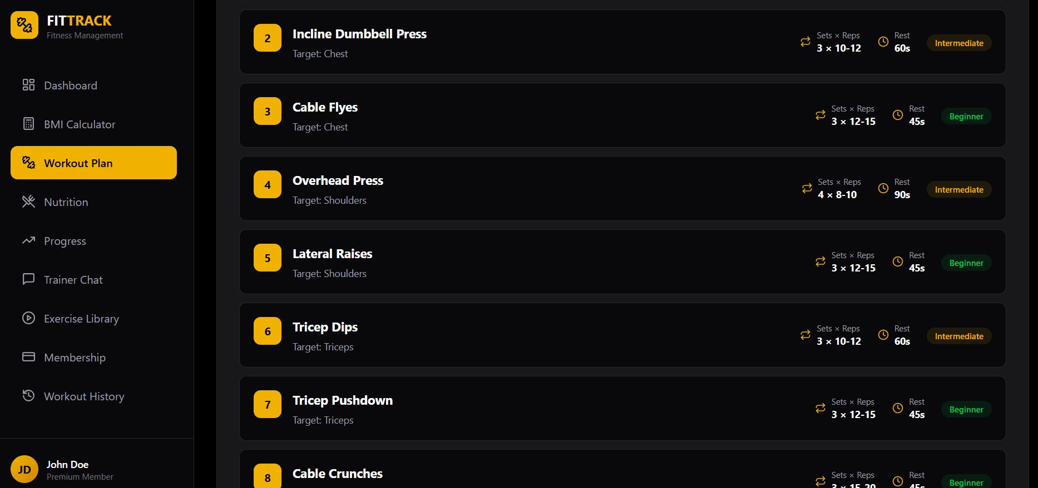
Figure 4: Workout Plan – Detailed exercise list with sets, reps, rest time, and difficulty level
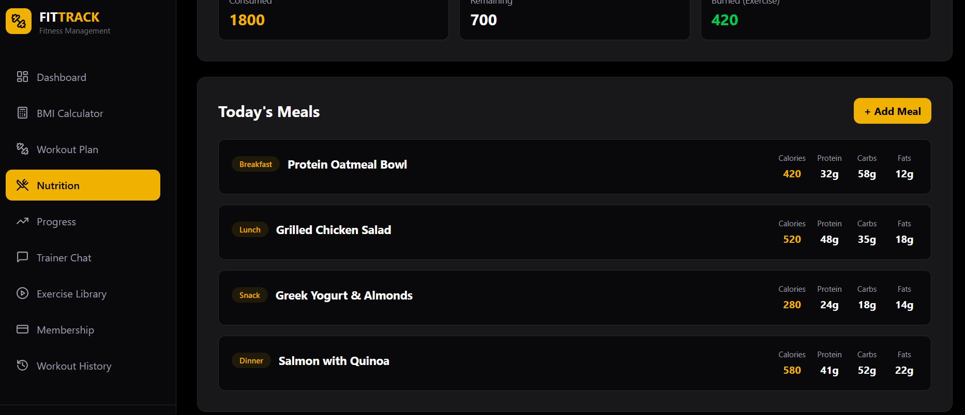
Figure 5: Nutrition – Today's meal log showing breakfast, lunch, snack, and dinner with macros
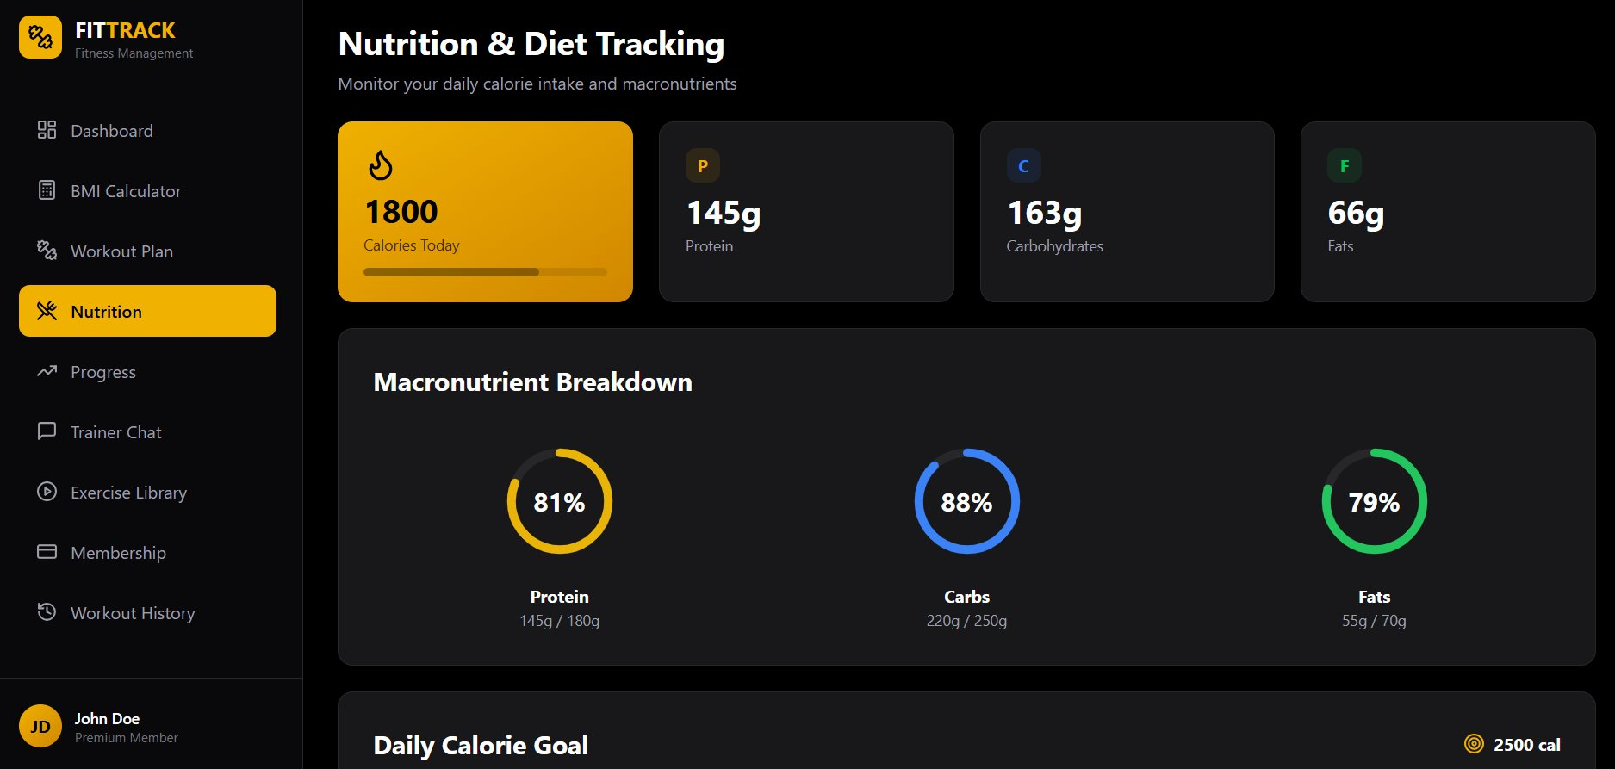
Figure 6: Nutrition & Diet Tracking – Macronutrient breakdown with circular progress indicators
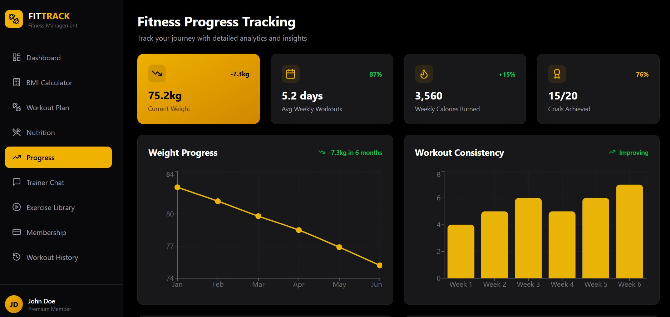
Figure 7: Fitness Progress Tracking – Weight progress chart, workout consistency, and goal stats
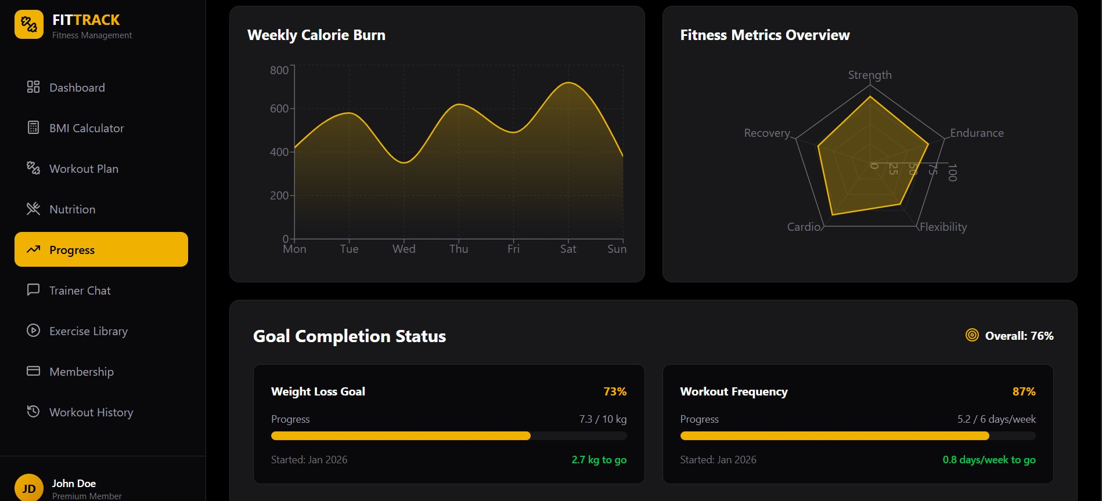
Figure 8: Progress – Weekly calorie burn chart, fitness metrics radar, and goal completion status
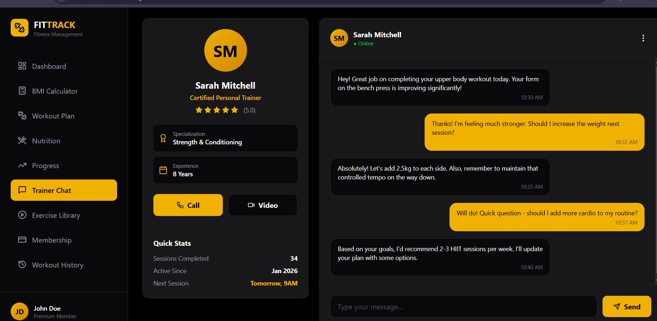
Figure 9: Trainer Chat – Real-time chat interface with certified personal trainer Sarah Mitchell
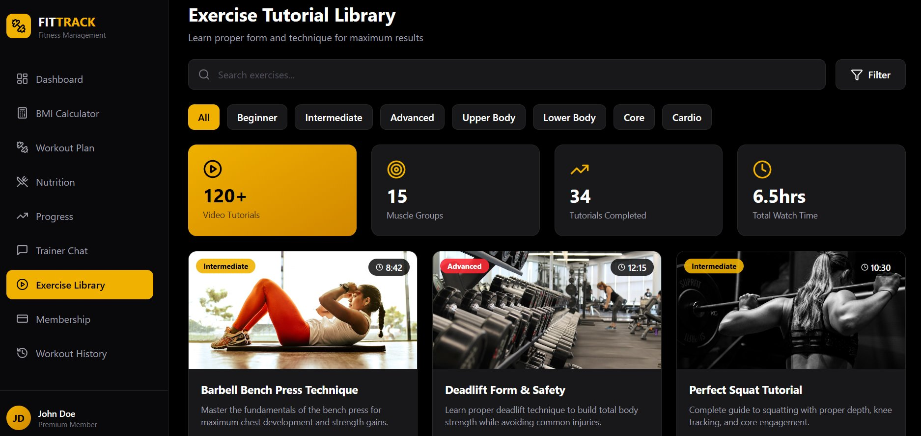
Figure 10: Exercise Tutorial Library – Searchable library with 120+ video tutorials and filter options
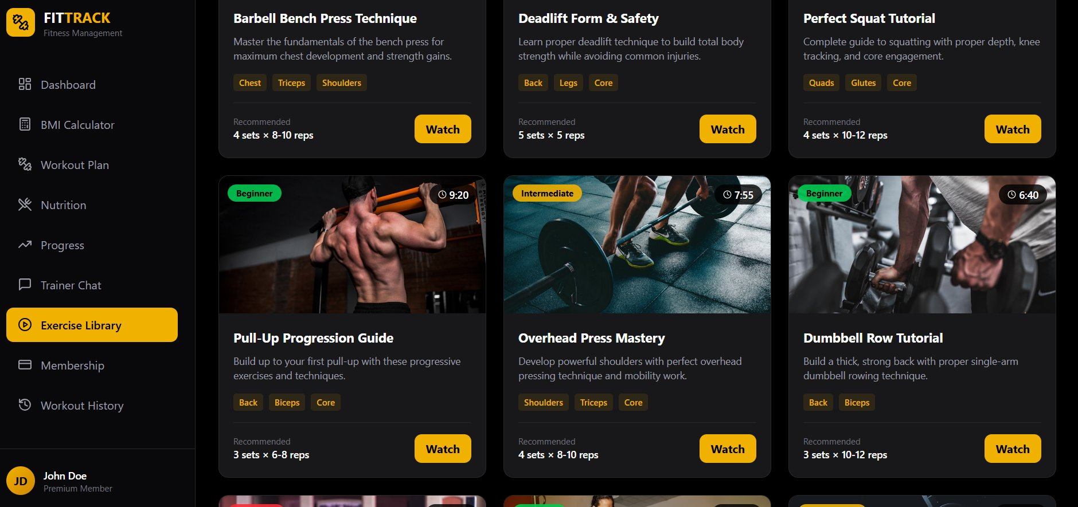
Figure 11: Exercise Library – Tutorial cards with muscle group tags, recommended sets/reps, and watch button

1.2 Implementation – Major Module
The major module implemented is the Dashboard, Nutrition, and BMI Calculator module. This module provides users with a comprehensive overview of their fitness journey, including calories burned, weekly goals, BMI index, and weight progress. It includes interactive charts for weekly calorie burn and workout duration, along with a detailed progress tracking page that displays weight loss trends and other fitness metrics.
The module enables users to monitor their daily activities, manage nutritional information, and track their physical progress efficiently through a user-friendly interface.

Technologies used: React.js for frontend, Node.js/Express for backend, MySQL for database

GitHub Link:
https://github.com/orion-pax09/FitTrack_system.git

1.3 Implementation – Minor Module
The minor module implemented is the Trainer–Client Communication and Progress Recording System. This module allows trainers and clients to communicate effectively through a chat-based interface and helps maintain user fitness records.
Additionally, the module includes a BMI Calculator feature where users can enter their height and weight to instantly calculate their Body Mass Index (BMI). The system displays the BMI result along with a color-coded BMI scale and category references such as Underweight, Normal, Overweight, and Obese to help users better understand their health status.
This module improves interaction between trainers and clients while also assisting users in monitoring their health and fitness performance.
Technologies Used:
- Frontend: HTML, CSS, JavaScript
- Backend: Node.js
- Database: MySQL
GitHub Link:
https://github.com/orion-pax09/FitTrack_system.git

1.4 Implementation Guidelines
Follow the steps below to run the FitTrack project locally:
Step 1: Download or clone the project repository from GitHub:
git clone https://github.com/orion-pax09/FitTrack_system.git
Step 2: Open the project folder in Visual Studio Code or any code editor.
Step 3: Navigate to the frontend folder of the project.
Step 4: Open the index.html file in your browser to launch the application interface.
Step 5: Create a new user account using the registration page.
Step 6: Log in with your account credentials.
Step 7: Explore the different modules available in the system, including:
  - Dashboard
  - BMI Calculator
  - Nutrition Tracking
  - Workout Tracking
  - Trainer–Client Chat System
  - Progress Monitoring
Step 8: Use the features to add workout records, calculate BMI, monitor fitness progress, and communicate with trainers through the chat system.
GitHub Repository:
https://github.com/orion-pax09/FitTrack_system.git

1.5 Demo Video
A complete demo video has been recorded showcasing both the major module and the minor module. The video includes a voice-over walkthrough explaining each feature, navigation flow, and functionality of the implemented modules.

YouTube Link:
https://youtu.be/SeysJhk3rlE?si=BJSvcxHiLQgagzAH

References
The following references were consulted during the design and development of this assignment:

[1] Figma Inc. – Figma Design Tool. Available at: https://www.figma.com
[2] React.js Documentation – Building User Interfaces. Available at: https://reactjs.org
[3] Node.js Foundation – Node.js Official Documentation. Available at: https://nodejs.org

